***Location Based:***

AREA 1 – Trinity County

AREA 2 – Sutter County

AREA 3 – Madera County

AREA 4 – Kern County

AREA 5 – Riverside County

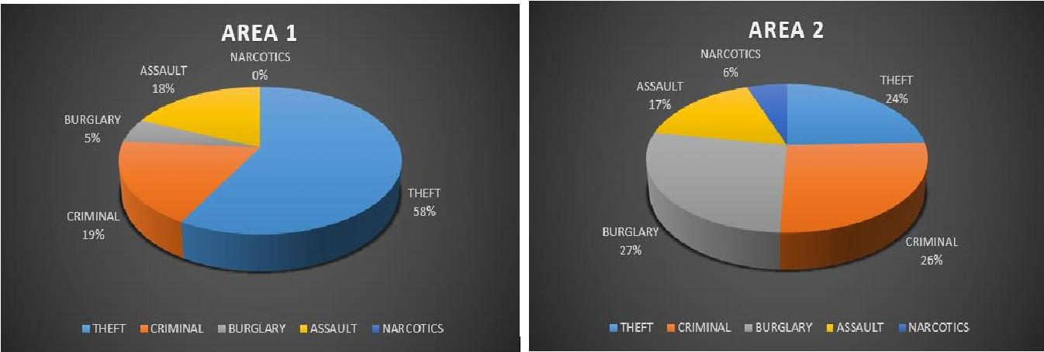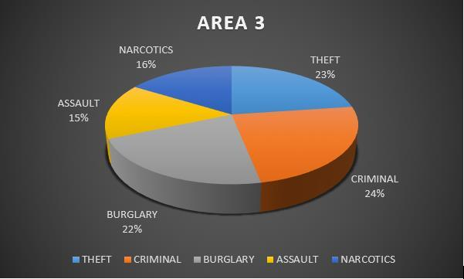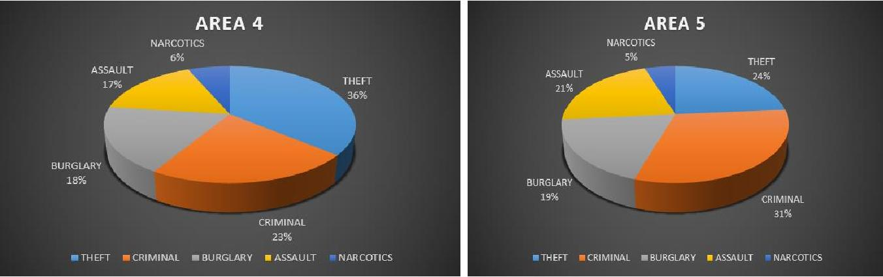

***Time Based:***

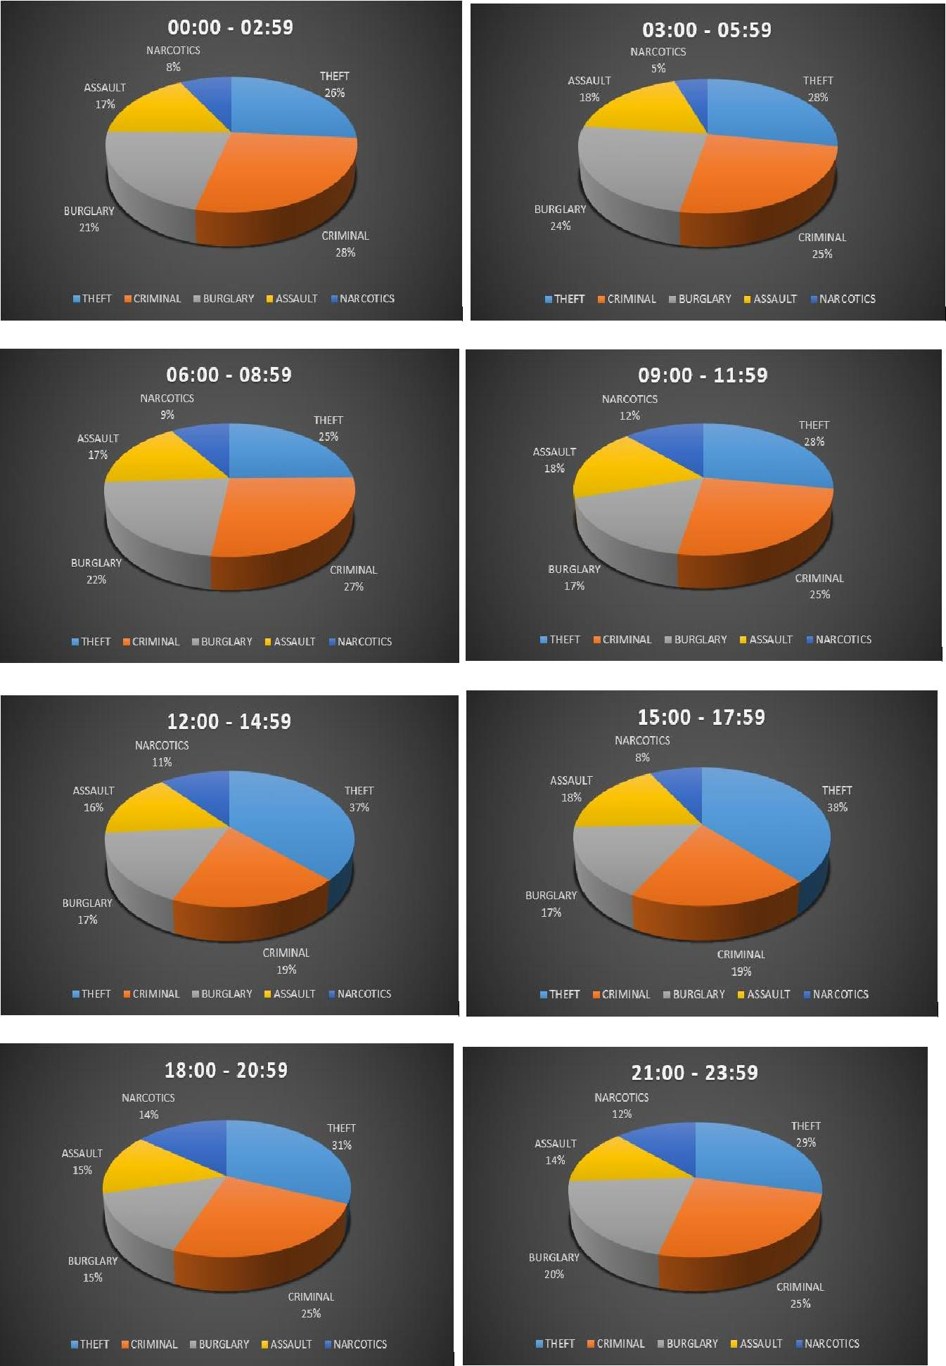

|  |  |  |  |  |  |  |  |  |
| --- | --- | --- | --- | --- | --- | --- | --- | --- |
|  |  | **THEFT** | **CRIMINAL** | **BURGLARY** |  | **ASSAULT** |  | **NARCOTICS** |
|  |  |  |  |  |  |  |  |  |
| **00:00 -** |  | 396 | 415 | 320 |  | 255 |  | 119 |
| **02:59** |  |  |  |  |  |  |  |  |
|  |  |  |  |  |  |  |  |  |
| **03:00 -** |  | 476 | 426 | 408 |  | 309 |  | 85 |
| **05:59** |  |  |  |  |  |  |  |  |
|  |  |  |  |  |  |  |  |  |
| **06:00 -** |  | 516 | 567 | 459 |  | 351 |  | 190 |
| **08:59** |  |  |  |  |  |  |  |  |
|  |  |  |  |  |  |  |  |  |
| **09:00 -** |  | 668 | 603 | 419 |  | 435 |  | 287 |
| **11:59** |  |  |  |  |  |  |  |  |
|  |  |  |  |  |  |  |  |  |
| **12:00 -** |  | 644 | 323 | 297 |  | 268 |  | 186 |
| **14:59** |  |  |  |  |  |  |  |  |
|  |  |  |  |  |  |  |  |  |
| **15:00 -** |  | 443 | 224 | 193 |  | 205 |  | 91 |
| **17:59** |  |  |  |  |  |  |  |  |
|  |  |  |  |  |  |  |  |  |
| **18:00 -** |  | 393 | 307 | 189 |  | 183 |  | 180 |
| **20:59** |  |  |  |  |  |  |  |  |
|  |  |  |  |  |  |  |  |  |
| **21:00 -** |  | 266 | 233 | 187 |  | 125 |  | 114 |
| **23:59** |  |  |  |  |  |  |  |  |
|  |  |  |  |  |  |  |  |  |

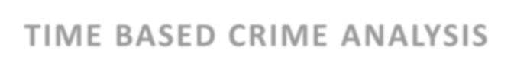

**TIME BASED CRIME ANALYSIS**

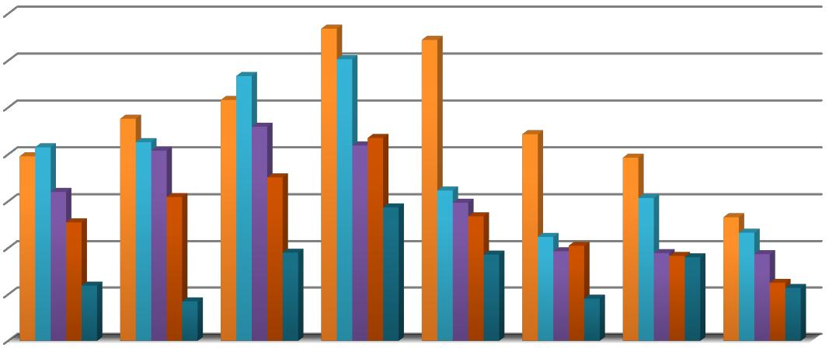

700

600

500

400

300

200

AREA 1 – Trinity County

AREA 2 – Sutter County

AREA 3 – Madera County

AREA 4 – Kern County

AREA 5 – Riverside County

|  |  |  |  |  |  |  |  |  |
| --- | --- | --- | --- | --- | --- | --- | --- | --- |
|  |  | **THEFT** | **CRIMINAL** | **BURGLARY** |  | **ASSAULT** |  | **NARCOTICS** |
|  |  |  |  |  |  |  |  |  |
| **AREA 1** |  | 22 | 7 | 2 |  | 7 |  | 0 |
|  |  |  |  |  |  |  |  |  |
| **AREA 2** |  | 164 | 176 | 182 |  | 112 |  | 37 |
|  |  |  |  |  |  |  |  |  |
| **AREA 3** |  | 1054 | 1112 | 999 |  | 708 |  | 748 |
|  |  |  |  |  |  |  |  |  |
| **AREA 4** |  | 2265 | 1413 | 1156 |  | 1038 |  | 402 |
|  |  |  |  |  |  |  |  |  |
| **AREA 5** |  | 297 | 390 | 233 |  | 266 |  | 65 |
|  |  |  |  |  |  |  |  |  |

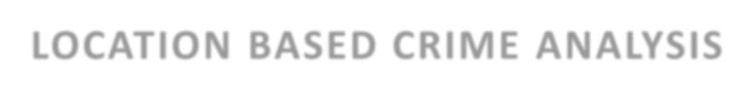

**LOCATION BASED CRIME ANALYSIS**

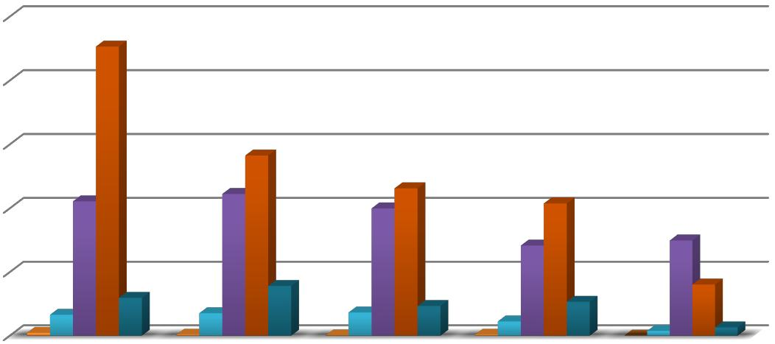

2500

2000

1500

1000

500

0

THEFT CRIMINAL BURGLARY ASSAULT NARCOTICS

 AREA 1  AREA 2  AREA 3  AREA 4  AREA 5